Task on CloudFront & Route 53
- Configure VPC peering in cross regions.
Created two VPCs in different regions with non-overlapping CIDR ranges.
Added subnets in both VPCs for resource placement.
Created cross-region VPC peering connection.
Accepted peering request in peer region.
Updated route tables with peering routes.
Configured security groups to allow inter-VPC traffic.

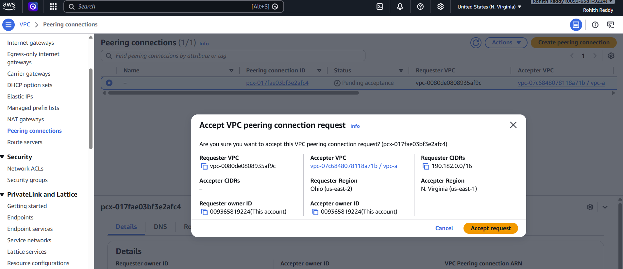

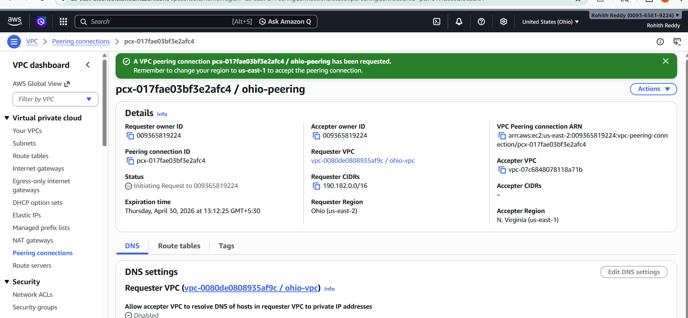

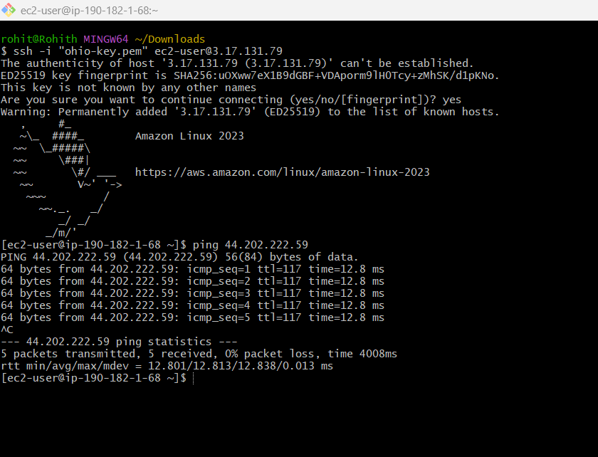
- Purchase one domain from GoDaddy.

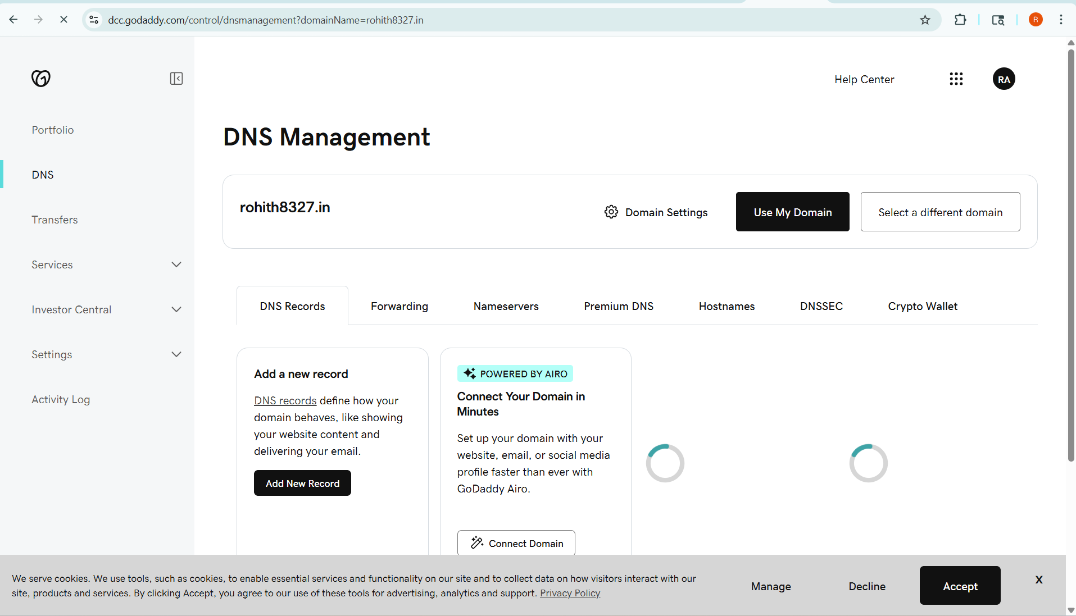

- Deploy static website in S3.

- Created an S3 bucket in Amazon S3 with a globally unique name.
- Disabled block public access settings to allow public website hosting.
- Uploaded static website files (index.html) to the bucket.
- Enabled static website hosting and configured index.html as the default document.
- Applied bucket policy to allow public read access to objects.
- Verified website accessibility using the S3 static website endpoint.

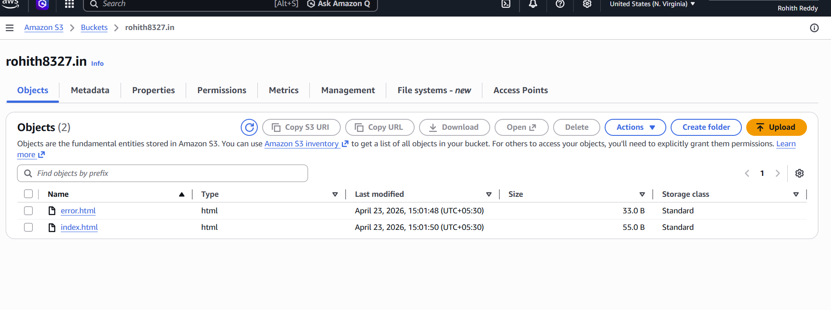

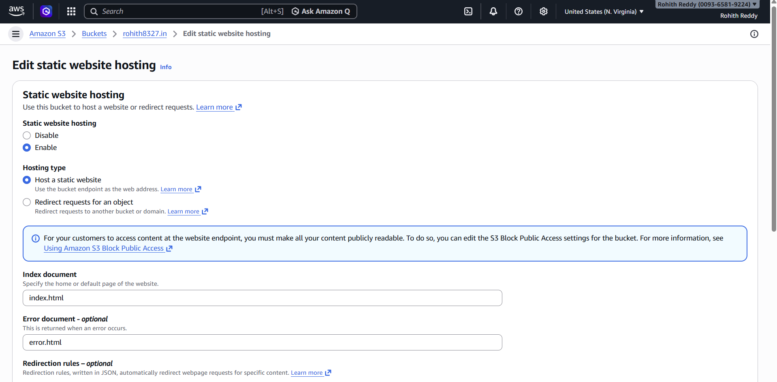

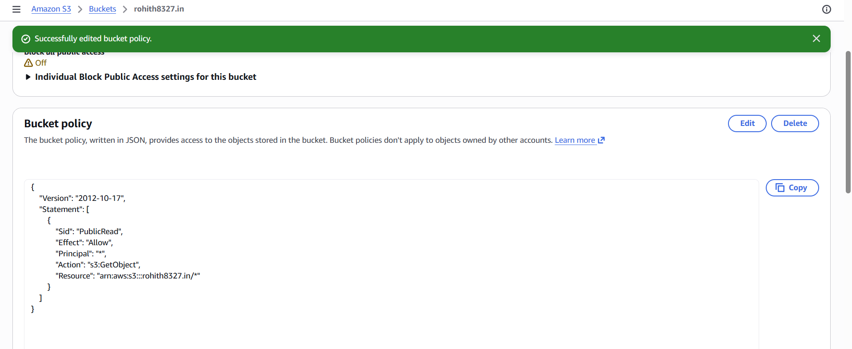

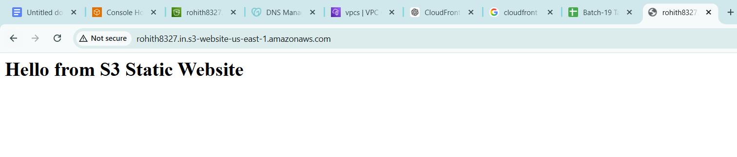

- Create a CDN and attach one SSL certificate.

Requested a public SSL certificate in AWS Certificate Manager for the domain and subdomain.
Completed DNS validation by adding CNAME records in GoDaddy.
Verified certificate status as Issued in ACM.
Created a CDN distribution using Amazon CloudFront with S3 static website as origin.
Configured alternate domain names (CNAMEs) and attached the SSL certificate to the distribution.
Verified successful deployment and HTTPS access via CloudFront URL.

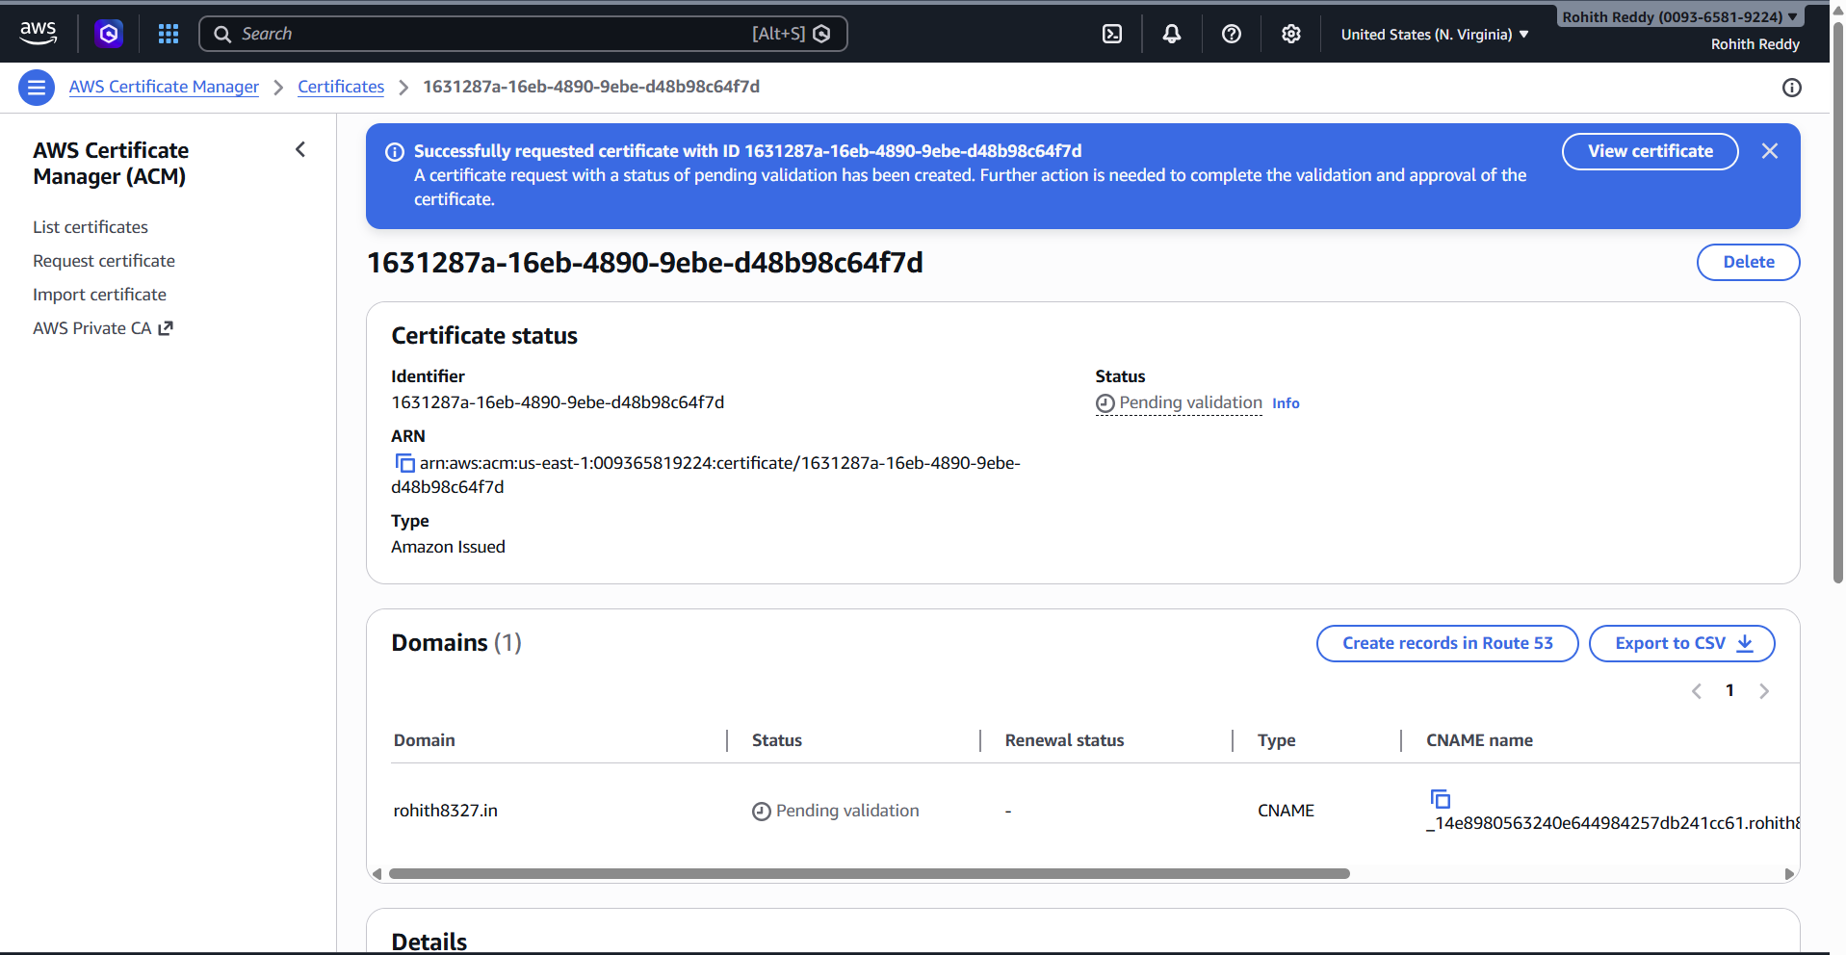

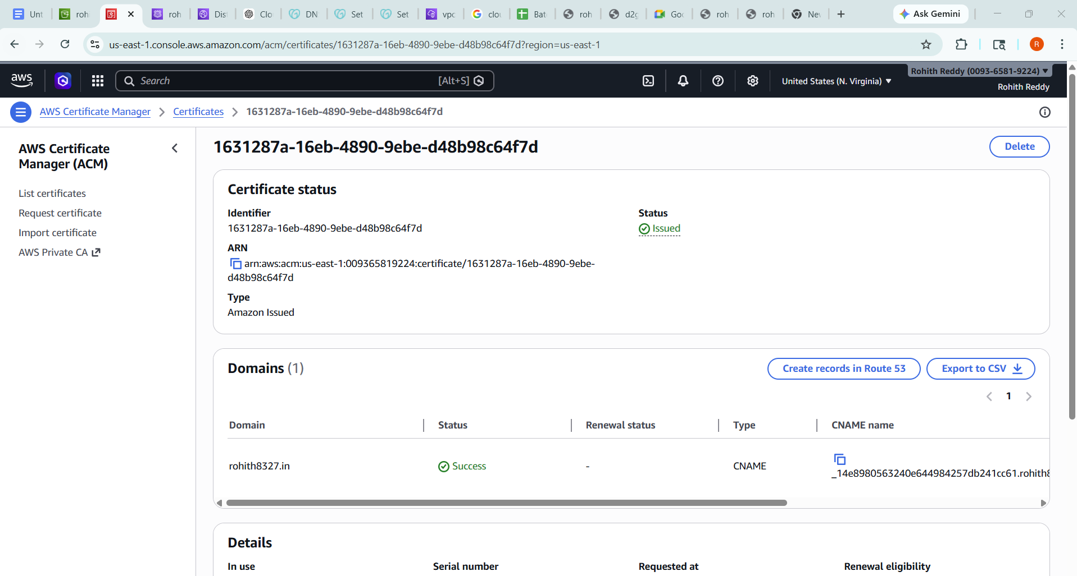

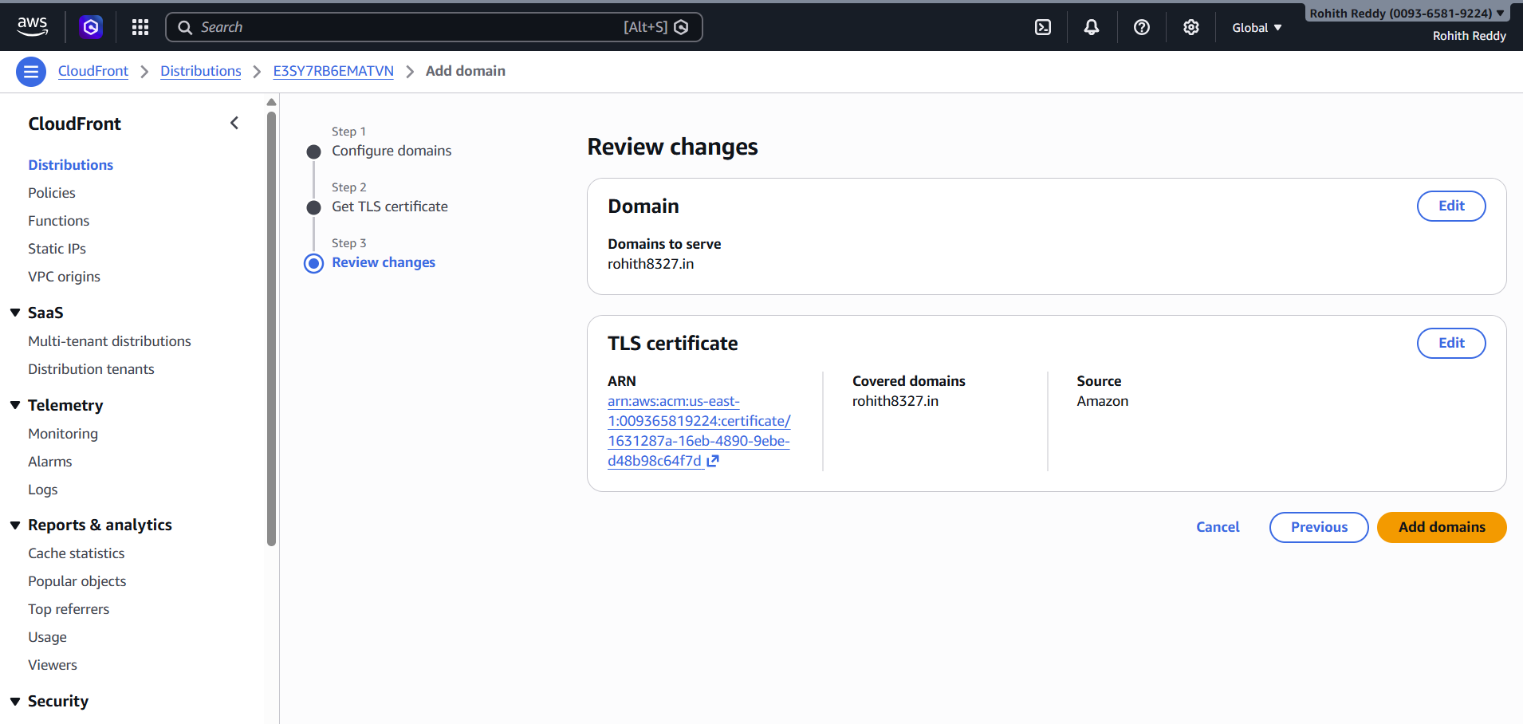

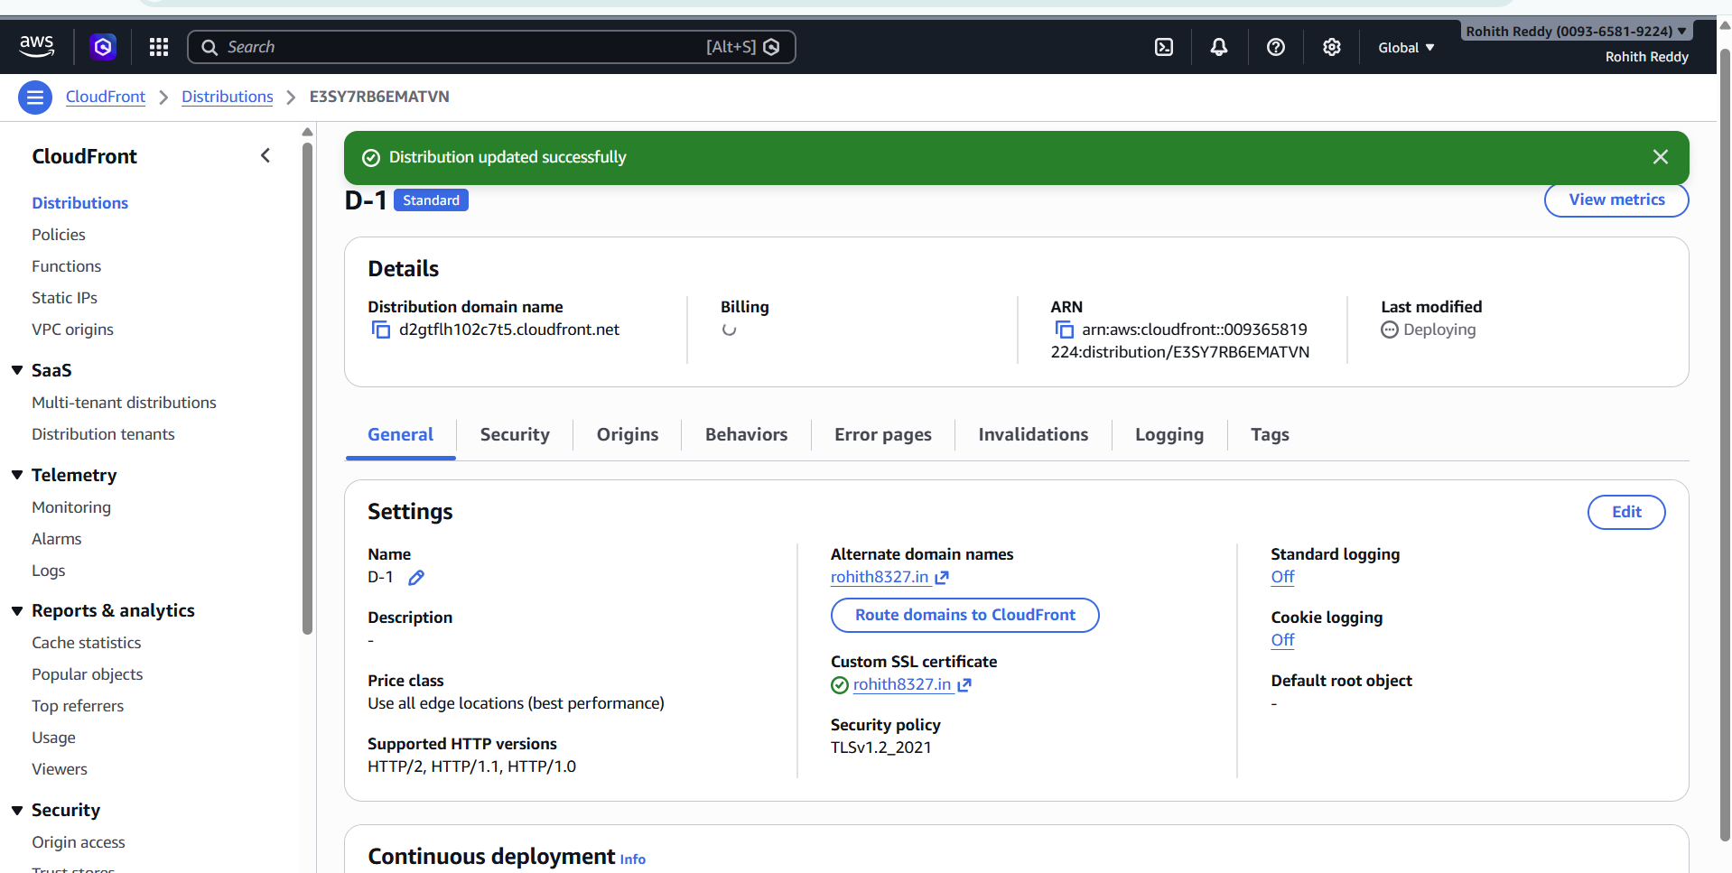

- Create a Route 53 hosted zone and map the domain with the CDN.

Created a public hosted zone in Amazon Route 53 for the purchased domain.
Retrieved NS (Name Server) records from the hosted zone.
Updated domain nameservers in GoDaddy with Route 53 NS records.
Created an A record (Alias) in Route 53 for the root domain.
Mapped the alias record to Amazon CloudFront distribution.
Verified domain resolution by accessing the website via the custom domain.

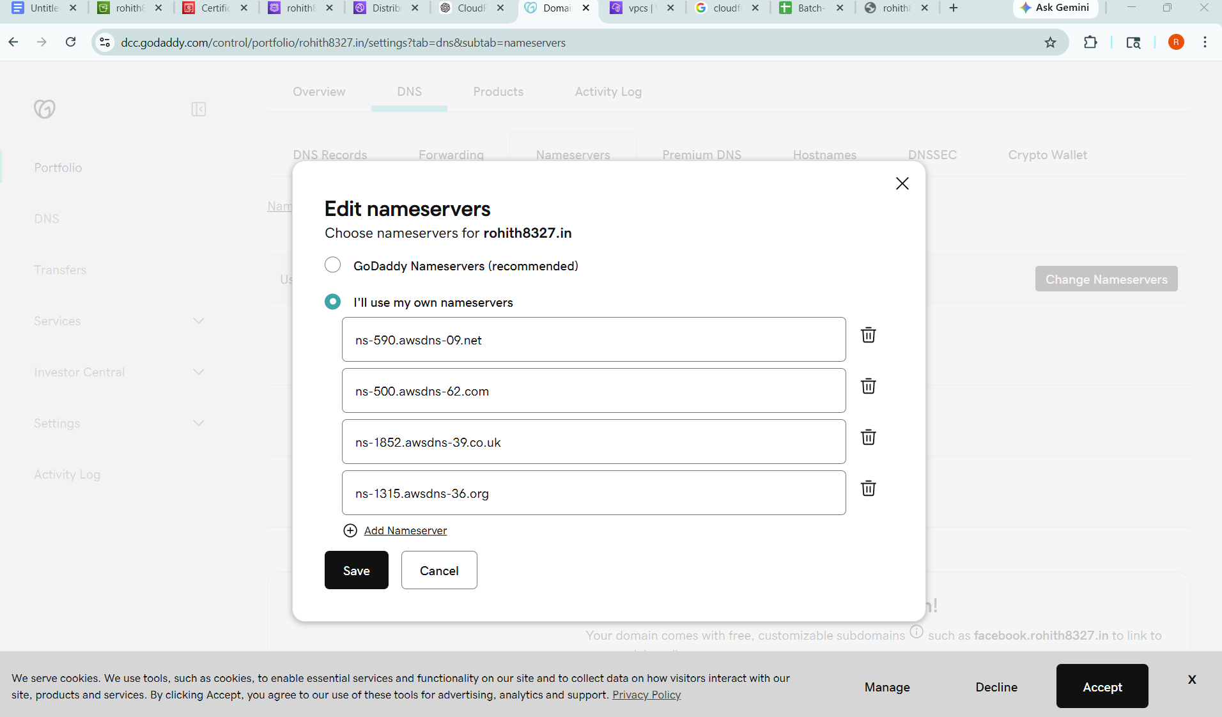

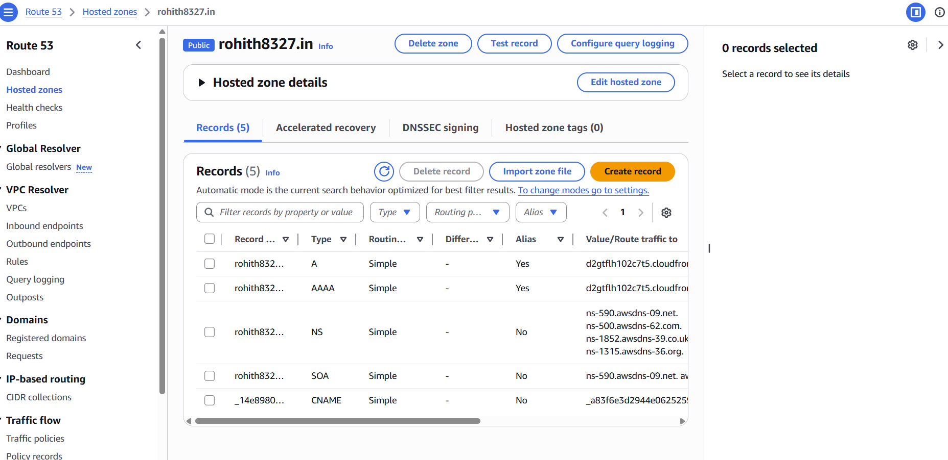

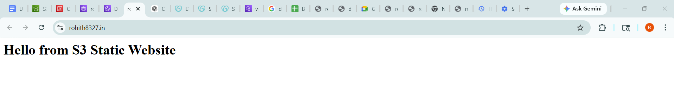

- Update the index.html in the S3 bucket and ensure the updated file is accessible using the domain name.

Modified the index.html file locally with updated content.
Uploaded the updated index.html to the S3 bucket in Amazon S3, replacing the existing file.
Verified the file update in the S3 bucket by checking object version/last modified time.
Accessed the website via the Amazon CloudFront URL to confirm content update.
Cleared CloudFront cache (invalidation) to reflect the latest changes.
Verified the updated website content using the custom domain configured in Amazon Route 53.

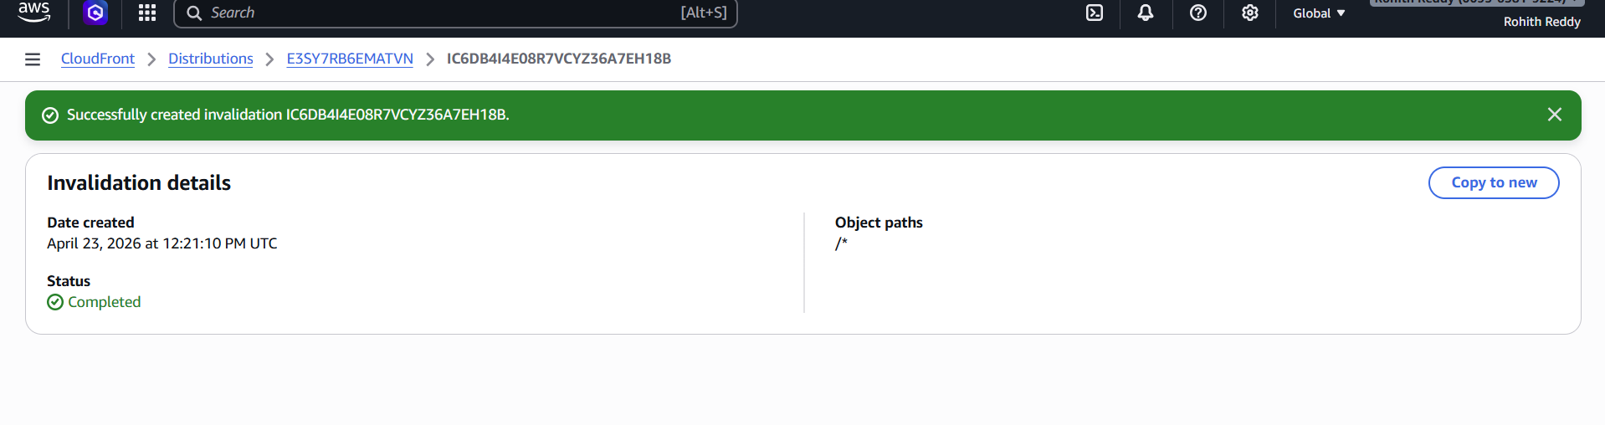

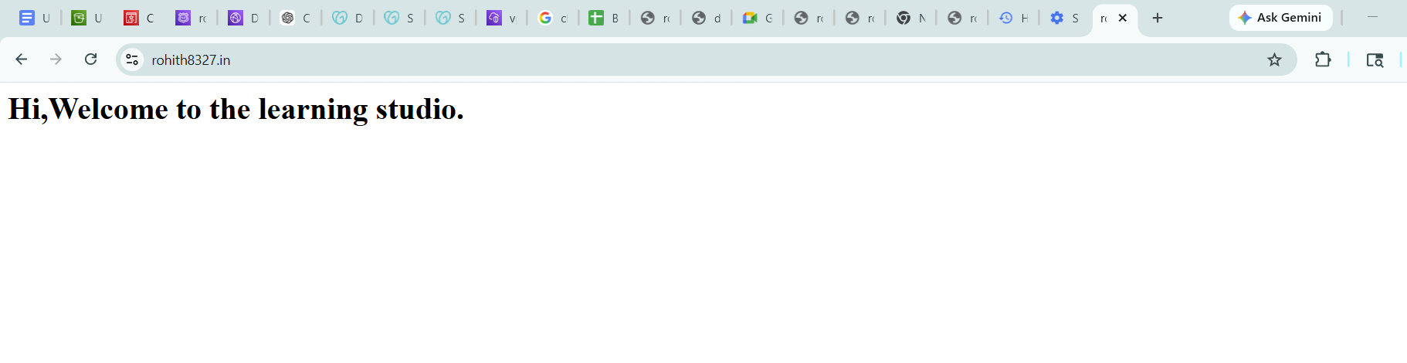

- Share the domain name in Slack to test the connectivity.

